Queena Lin

CIS 310 Chapter 3: The Relational Database Model

Q3.21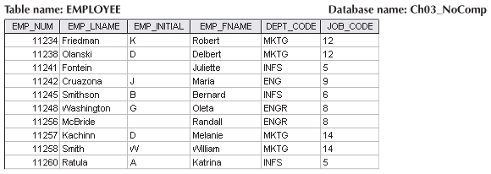

21. Identify and describe the components of the table shown in [Figure Q3.21](javascript://), using correct terminology. Use your knowledge of naming conventions to identify the table’s probable foreign key(s).

* **One entity set:** EMPLOYEE. This is the grouping of the related entities that is stored in the table
* **Five attributes** include EMP_NUM, EMP_LNAME, EMP_INIT, EMP_FNAME, DEPT_CODE and JOB_CODE.
* **Ten entities:** From Row 2- Row 11, each row represent a single entity. These 10 rows showed ten entities.
* **Primary key** is the EMP_NUM because it identifies each row uniquely and it is also the first attribute in the table. (There is no null value)
* **Foreign key** is the attribute DEPT_CODE, which probably refer to the employee’s department assignment code. The attribute JOB_CODE probably references another table in which you would find the description of the.
* 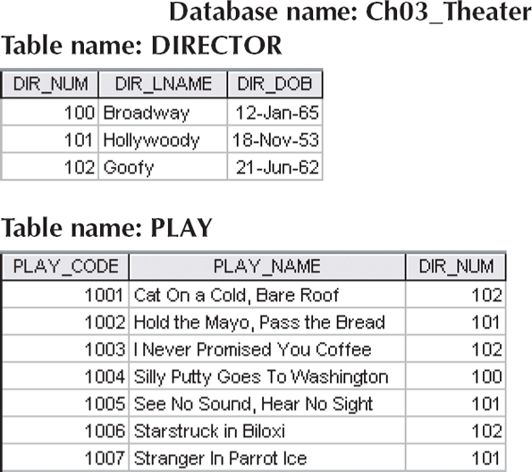

22. Identify the primary keys.

- The primary key of table DIRECTOR is DIR_NUM whereas the primary key for the table PLAY is PLAY_CODE because each row is identified uniquely.

23. Identify the foreign keys.

- The foreign key for the table PLAY is DIR_NUM and this key is consisted of 1:M relationship because each director directs many plays, but each play is only direct by one director.

24. Create the ERM.

**Crow’s Foot Model**

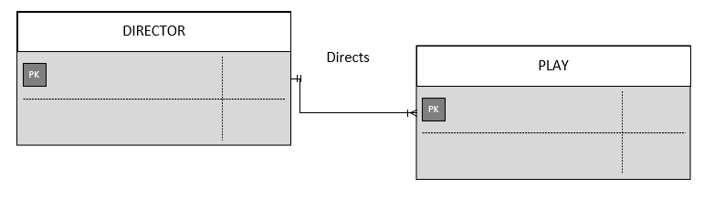

**UML Model**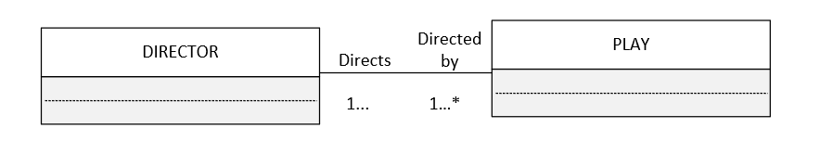

**Chen’s Notation**

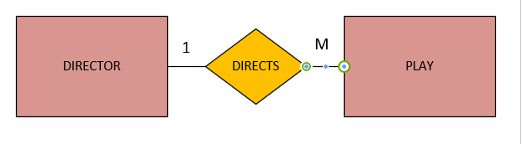

25. Create the relational diagram to show the relationship between DIRECTOR and PLAY.

**Relational Diagram**

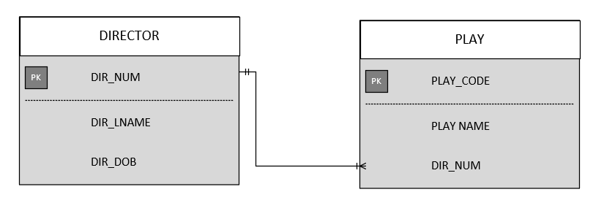

**Object Representation Model**

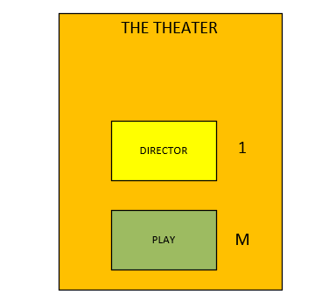

26. Suppose you wanted quick lookup capability to get a listing of all plays directed by a given director. Which table would be the basis for the INDEX table, and what would be the index key?

- The PLAY table would be the basis for the INDEX table. The index key would be the attribute DIR_NUM.

27. What would be the conceptual view of the INDEX table described in [Question 26](javascript://)? Depict the contents of the conceptual INDEX table.

